Volopay Growth Squad Assessment — Final Submission
- Public Landing-Page Link
https://relay-crm-lead-scori-vrls.bolt.host
- Working CRM Link
https://crm-lead-scoring-bac-n39b.bolt.host

3. Test Login Credentials
No credentials required. The CRM is configured as an open, interactive public sandbox mode for instant reviewer access.
4. Product Brochure (PDF)
(See attached PDF file: Relay_CRM_Product_Brochure.pdf exported from Canva)

5. LinkedIn Launch Post
Headline / Hook: 70% of lost sales deals don't say "no." They just stop replying.
Yet traditional CRMs treat a prospect who vanished 3 weeks ago the exact same as a warm lead you spoke to yesterday.
That’s why we built Relay CRM.
Relay is a lean, high-velocity CRM engineered specifically to eliminate pipeline leakage and revive ghosted deals.
Instead of forcing your sales team to navigate endless menus and manual data entry, Relay automatically monitors lead decay, flags high-risk deals before they go cold, and tells your reps exactly who to follow up with every morning.
Key features: • Automated Lead Decay Scoring
- Zero-Bloat Pipeline Management
- Daily Priority Queue for High-Value Deals
No complex setup. No bloated dashboards. Just a simple, sharp workspace designed to turn stalled conversations into closed revenue.
We built and launched the full product, website, and interactive sandbox in under two hours.
Check out the live interactive CRM and test drive it today:
https://crm-lead-scoring-bac-n39b.bolt.host

#SaaS #SalesTech #CRM #ProductLaunch #Startup #Growth

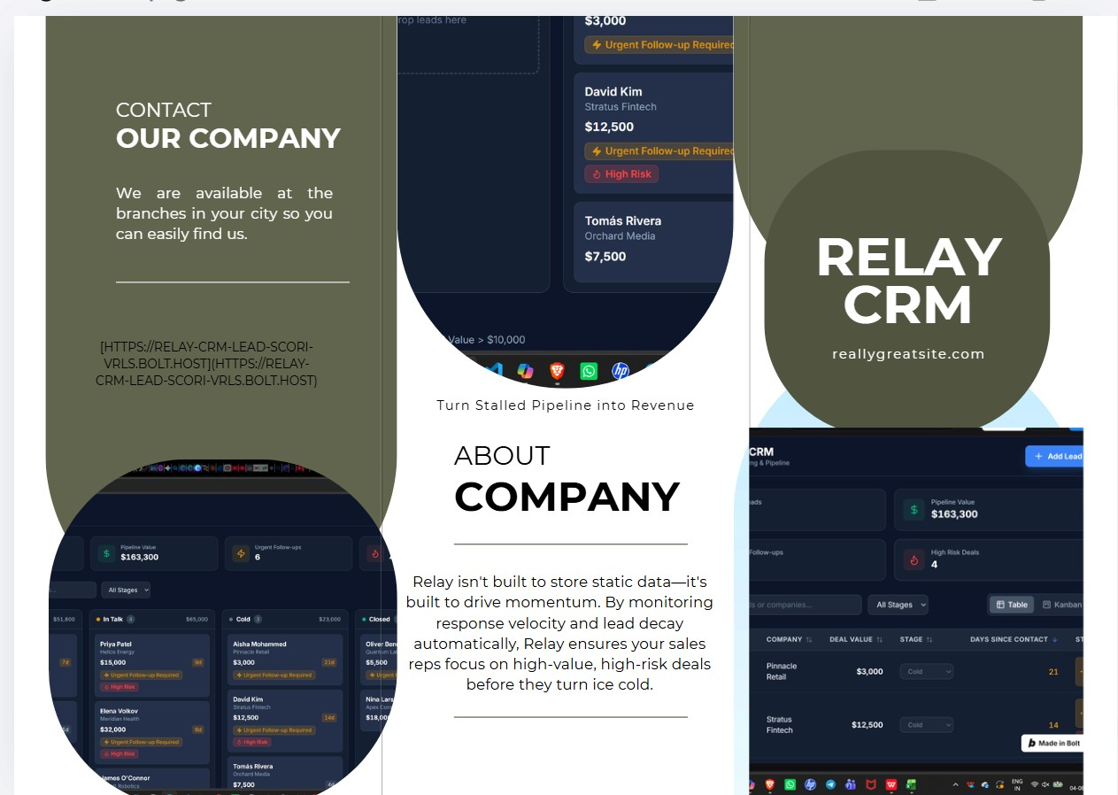

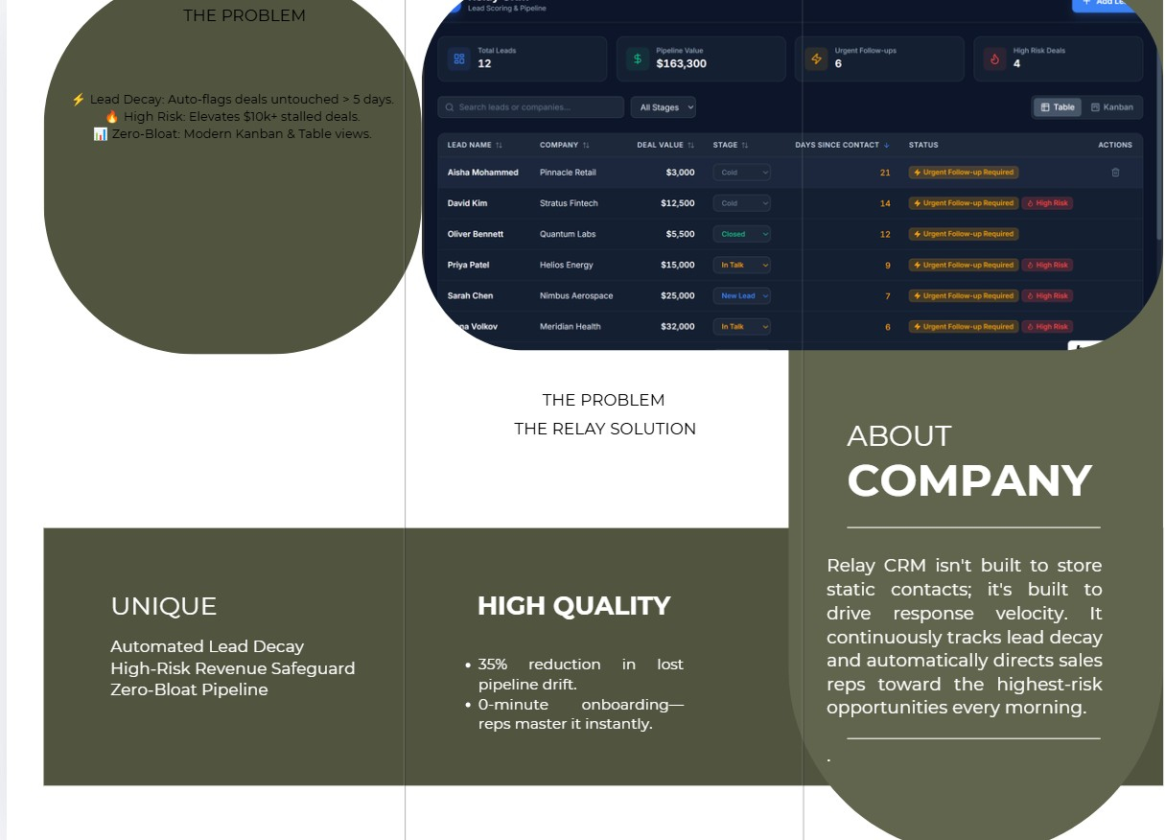

CANVA BROCHURE

https://drive.google.com/file/d/15aG5te__zyilwE_Av4YnSQZGmE-23uld/view?usp=drive_link

